Wang Zhi-zhou
Room 420, Building 39, Tianjin University, Tianjin 300072, China
Phone: +86 15102272032 Email: wangzhizhou2015@qq.com
Nationality: Chinese

OBJECTIVE
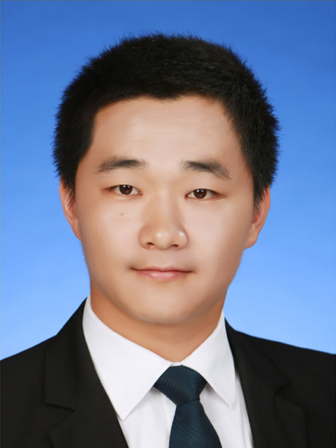
I apply for the software engineer position.

PROJECT EXPERIENCE
Sep, 2014  TO  Feb, 2015 | Vehicle license plate recognition system  Assigned tasks: adjust the algorithm to achieve higher recognition rate
Sep, 2014  TO  Feb, 2015 | Project description:
 | We preprocess and segment all possible parts of an image, and we use a Support Vector Machine(SVM) algorithm to decide if each segment is(or is not) a license plate. For each detected plate, we use an Artificial Neural Network(ANN) algorithm to recognize the character.
Sep, 2013  TO  Mar, 2015 | Intelligent traffic vehicle recognition system  Assigned tasks: design the desktop(Windows xp) software
Sep, 2013  TO  Mar, 2015 | Project description:  We use radar velocimeter, laser range finder and web camera to obtain the information of vehicle. The desktop software communicate with those hardware devices and process the information obtained. According to the classification algorithm, vehicle is judged to be one of the six specified models.
Sep, 2013  TO  OCT, 2014 | The Yellow grid line area parking detection system  Assigned tasks: refine algorithm and graphic user interface, design the illegal record browser  Project description:  We use web camera to detect a specified yellow grid line area, the captured real-time images are sent to industrial personal computer to be processed. If some vehicles are detected parking, a record about that vehicle is saved and sent to the traffic control center server.

EDUCATION BACKGROUND:
Sep, 2013  TO  Present | School of Electrical Engineering and Automation, Tianjin University, Tianjin, China  Master candidate, Control Science and Engineering
Sep, 2013  TO  Present | - GPA=3.16,  - Research Area: Intelligent transportation system and image processing  - Correlated curriculum: Computer Vision, Artificial intelligence and Applications, Pattern recognition;
Sep, 2009  TO  Jul, 2013 | School of Information Engineering, Nanchang University, Jiangxi, China  Bachelor, Automation
Sep, 2009  TO  Jul, 2013 | - GPA=3.7  - Correlated curriculum: Object oriented C++ program design, Operating system principle, Data structure, Computer network;  - Final Year Project: The Design of MP3 Player;

TECHNICAL SKILL:
Platform |  | WINDOWS XP/7/8.1, LINUX(Fedora)
Languages |  | C, C++, C#
Software |  | - MS VS development tool;  - MFC Application Framework;  - OpenCV Image Processing Library  - Matlab, Mathematica

Others
 |  | Pasted NCRE-3(Network) & NCRE-2(C)

LANGUAGE:
- Chinese (Native)
- English (Fluent): CET-6(470)、CET-4(478)
SELF-EVALUATION
Easy-going and congenial, with a strong sense of responsibility and good team-spirit, patient, have holding capacity to pressure and setback

